**Unlock EEG Setup Checklist:**

1. 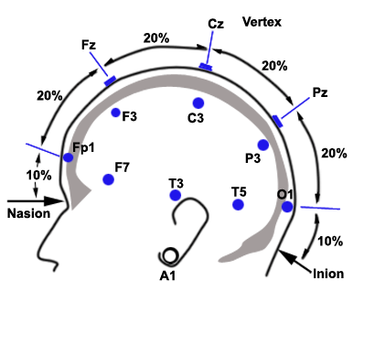*EEG Cap electrodes:*

|  |  |
| --- | --- |
|  | FP1 |
|  | Chest/Chin straps |
|  | EEG gel |
|  | EEG syringe |
|  | Nuprep gel |
|  | Q-tips |
|  | Measuring Tape |
|  | Medical tape |
|  | Alcohol swab |

Fig. 1. http://www.gtec.at/Support-Offer/FAQ/Tips

1. *Application:*

|  |  |
| --- | --- |
|  | Follow the EEG Setup Checklist, for EEG cap placement, found in the wiki. |
|  | In the spreadsheet fill out all fields, specially the subject, who places the cap, location of reference electrode, and protocol parameters. |
|  | . |
|  | Ask subject to put chest strap under arms with buttons in the front. |
|  | Put on gloves. |
|  | Measure distance from Nasion to Inion (see Fig. 1); have subjects indicate where Inion is. Record distance in Lab Notebook as well as the mid line (Cz). |
|  | Place EEG cap on head (use correct size), ensuring chin straps are on the cap. |
|  | Cross connect chin straps to chest strap. |
|  | Tighten EEG cap elastic cord at the back and flat it avoiding excessive bumps or air pockets. |
|  | Ensure Cz is half-way between Nasion and Inion. |
|  | Clean with alcohol swab and abrade ground electrode site (forehead) with Q-tip and Nuprep gel. Abrasion is done circularly to the point skin starts to turn red (be careful not to over-abrade). |
|  | Fill electrodes with gel by curing syringe tip back (starting closer to the electrode inner active/metallic surface) then simultaneously fill and pull out. |
|  | Clean EOG/EMG site(s, if any) with alcohol swab. |
|  | Place EOG/EMG electrode(s, if any) on adhesive washer, apply to skin and fill with EEG gel. |
|  | Clean with alcohol swab ear lobe. |
|  | Put EEG gel on ear-reference clip electrode and attach to ear’s cleaned area. |

1. Check Mobilab is pairing properly with the recording computer via Bluetooth.

Connect the gammaBox to the Mobilab wireless transmitter.

Turn on the gamma Box and the Mobilab wireless transmitter.

Check green LED in Mobilab is blinking (this means waiting for communication).

Check the Bluetooth dongle is connected to a USB port of the recording computer (usually Tongue) and its blue light is on **(see figure 1. Bluetooth dongle in USB port signaling proper functioning via a blue LED on)**

Go to Control Panel\Hardware and Sound\Devices and Printers

Find the device named MP-2010_09_06 (this is the one for the Mobilab).

Right click and select Remove the Device. Disconnect the Bluetooth dongle and turn off the Mobilab.

Connect the Bluetooth dongle and turn on Mobilab.

Go to Control Panel\Hardware and Sound\Devices and Printers

In Unspecified Devices (bottom if window) a new device will appear. Should be named HASP HL 3.25.

Now we need to pair this device to the Mobilab. To do so go to the task bar at the bottom right of the Windows screen and click the “Show hidden icons” arrow. Go to the “Bluetooth devices” icon and right click it. Click on “Add a device”. A new window will appear showing the Mobilab “MP-2010_09_06”. Click on this device and a textbox will request a pairing code. Type 1234 and hit enter.

A “Installing device” globe will pop up on the bottom right of the screen as well as the port number.

To confirm the Mobilab’s port number, go to Control Panel\Hardware and Sound\Devices and Printers

The Mobilab, MP-2010_09_06, should be listed in the “Devices” row

Right click it and go to Properties. In the Hardware tab, check the “Device Function” and the port used by the device.

Write down the port number since it will needed to update the port input in Unlock (usually COM6 or COM7).

Go to UInlock nd in the configuration file change the com port to match the one used by the Mobilab.

You should be all set to start recording.

Note: When starting to communicate with Mobilab, the blinking green LED should turn solid green (all the time on). If this does not happen a possible problem with the pairing or the communication has to be resolved.

Run a dummy recording session, a couple of seconds. The locate the data, right click it and left click on “Edit with Notepad++”. The number should be signed int16 numbers (integers between -65536 and 65536). If bigger or smaller numbers are present debug the communication of the device with Unlock (repeat pairing).

After each recording check the size of the file is somehow close to the time of recording. 700Kb for a minute of recordings (for 12 channels at int16).

Run a calibration session with the following artifacts

Clench jaw

Blink fast 10 times

Blink hard

Move eyes up and dow

Move eye left and right

Blink hard

Blink fast 10 times

Talk

Move head front and back

Move legs

Move arms